**2023 - 2024**

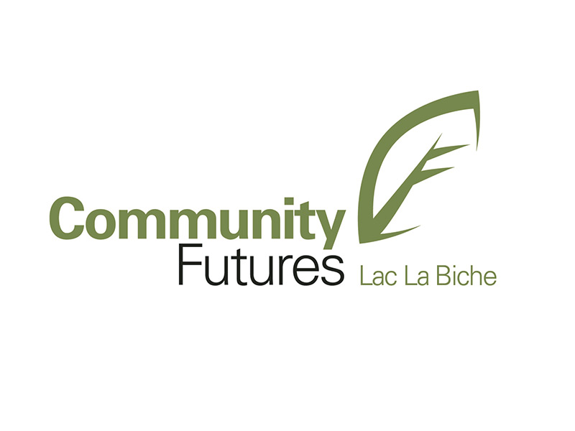

**Sustainability Plan**

[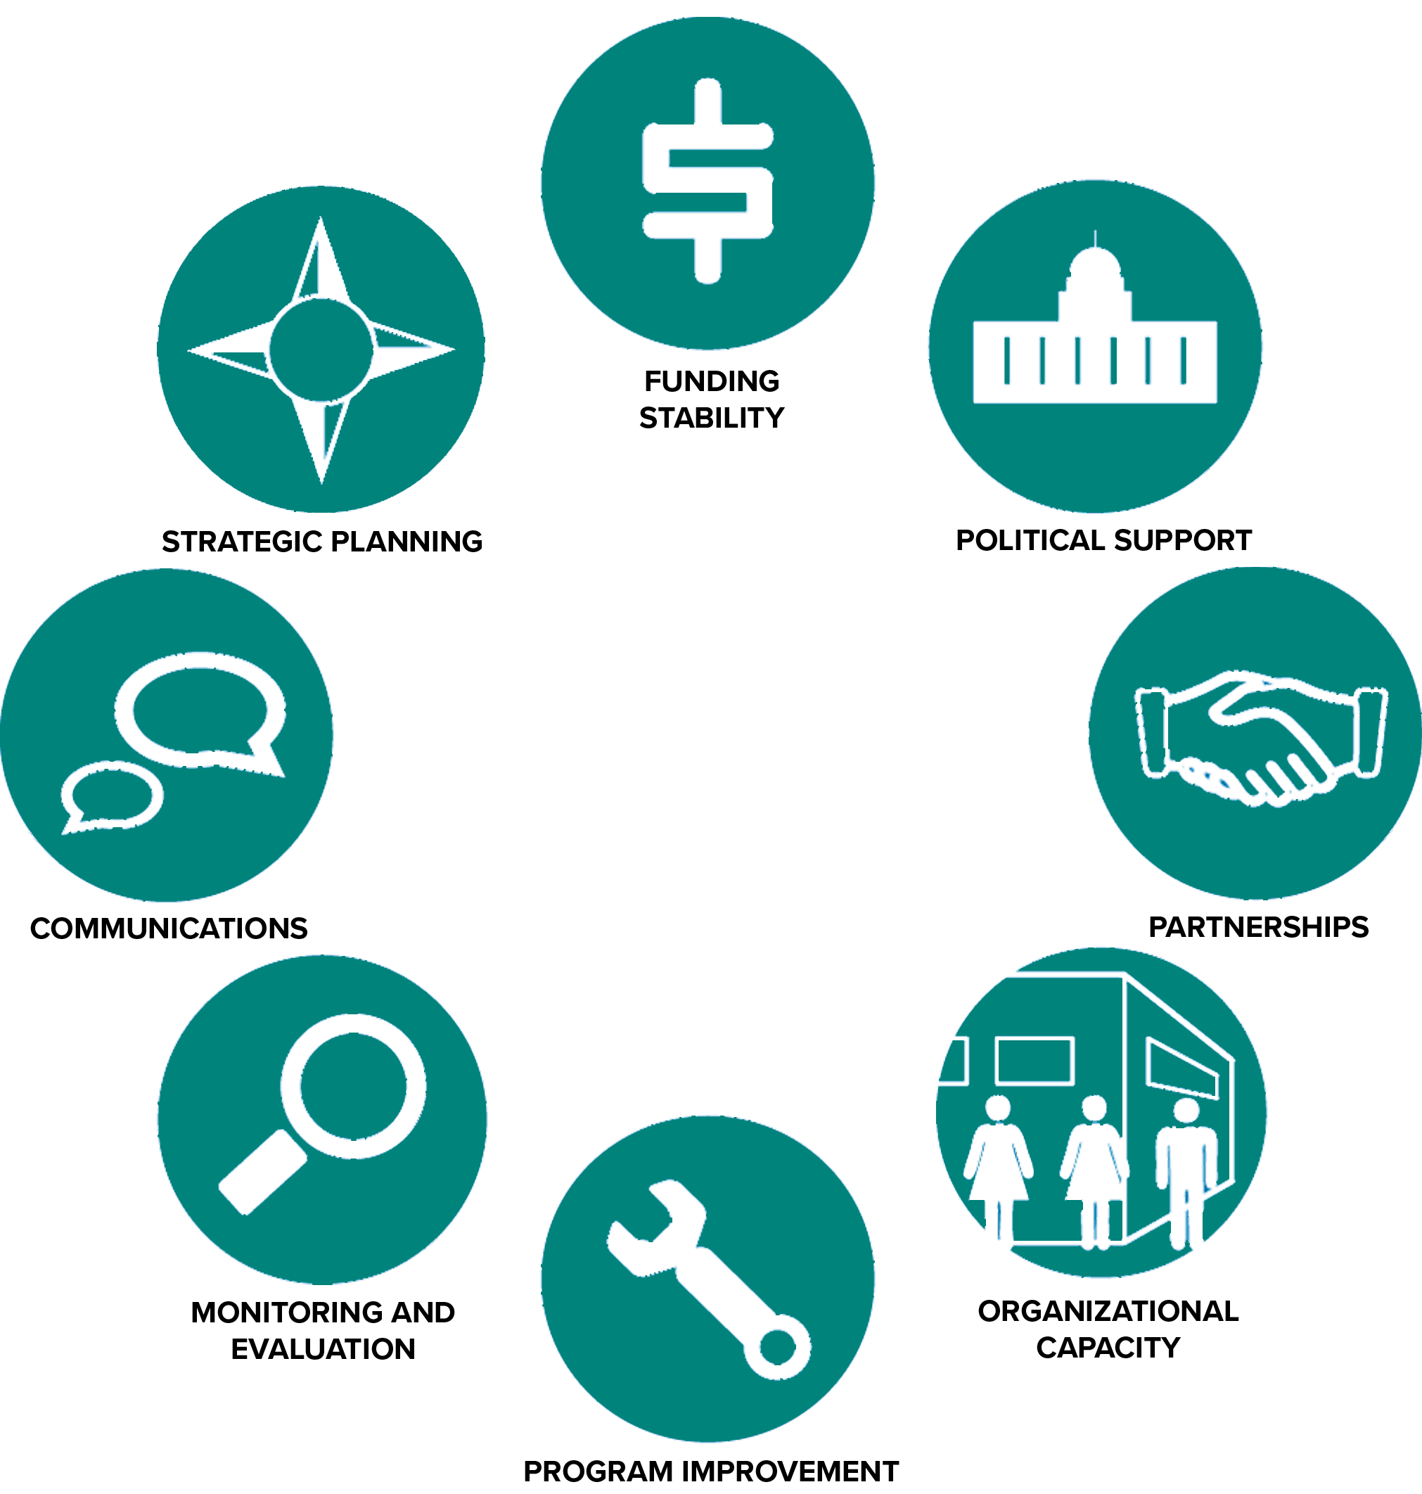](https://www.google.ca/url?sa=i&rct=j&q=&esrc=s&source=images&cd=&cad=rja&uact=8&ved=0ahUKEwj7lNPxi8XYAhUs34MKHYMPDaQQjRwIBw&url=http://sienaconsulting.ca/8-criteria-for-building-organizational-sustainability/&psig=AOvVaw1XbvlKtlFt_OZf6I9e_wY_&ust=1515388409907947)

**Focused Leadership Group**

**May 2023**

**Purpose**

**Option 1**

**We provide developmental opportunities for small business entrepreneurs.**

**We:**

1. **Support entrepreneurs to help ensure their success**
2. **Offer flexible financial loans to grow business ventures**
3. **Leverage provincial and federal business development programs**
4. **Stimulate economic growth and diversity.**

**Organizational Health Pillars**

The organizational pillars help provide balance between strategy and operational sustainability. Ultimately, they reflect the most critical aspects of the Community Futures Lac La Biche overall health and ongoing viability. Our annual operational and strategic priorities should encompass each of these pillars and the desired outcomes within.

**Desired Outcomes for Each Pillar**The following outcomes serve as a foundational framework for ongoing organizational success and sustainability EACH YEAR. These outcomes are the minimum required for the Community Futures Lac La Biche to be healthy and in a position to achieve its Purpose/Mandate.

|  |  |
| --- | --- |
| **Customers** | 1. Measurable business development, diversification, and growth occurs in the CFLLB as a direct result of our work. 2. Small business owners and entrepreneurs receive tangible support and assistance from our programs/services and our staff/advisors. 3. Our website and our social media platforms are up to date and easily advertise our services. 4. Relationships with our customers is collaborative and positive. 5. Opportunities exist for small business owners to learn new business management concepts. 6. Our funding programs, and administration thereof are user friendly for our customers. 7. A wide range of customers using our programs and services exists. 8. Current and prospective customers are educated on benefits of Community Futures Lac La Biche engagement and are fully aware of the expectations. 9. An effective customer engagement plan exists and is implemented/evaluated. 10. Exit interviews are conducted with customers no longer using our services to determine the tangible benefits they received. Termination trends are monitored and acted upon. 11. Opportunities to benefit customers and our business community are sought out and successfully implemented. |
| **Financial** | 1. Accurate and detailed financial reports exist for all customer funding programs 2. A balanced budget exists every month; and surplus money is planned for, and tracked. 3. A full annual budget is reviewed and approved by the Board. 4. Adhere to the specific reporting conditions of any funders and/or sponsors. 5. Clear explanation/evidence exists for all variances on budget. 6. Invoices are attached to cheques that need to be signed. 7. All employee/employer source deductions are paid in a timely fashion according to Revenue Canada. 8. Board member Director Liability insurance is in place and up to date. 9. Expenditure plan & Authorization is in place/followed. 10. Capital replacement & maintenance plan exists and is followed regularly. 11. Proper accounting principles are regularly followed/practised. |
| **Organization** | 1. An annual operational plan with priorities and actions exists to guide the work of the Board and staff. 2. Organizational by-laws, policies exist, comply with all required legislation, and are reviewed at least bi-annually. 3. Effective and professional working relationships exist between the Board and Leadership. 4. Low turnover rates in relation to industry standards exist with Community Futures Lac La Biche staff. 5. Organizational structural adheres to funding expectations and is reviewed bi-annually. 6. Organizational (staff thru to board) culture is positive and productive. 7. Compensation is competitive (to industry and geographic location) & fair across organization, and grids exist or all positions. 8. Staff roles and responsibilities are clearly detailed. 9. Staff are clearly aware of sustainability outcomes and their respective role towards meeting them. 10. All staff are actively engaged in the successful operations and initiatives of the Community Futures Lac La Biche. 11. Confidentiality of customer dealings and Community Futures Lac La Biche affairs are upheld at all times. 12. Performance of all staff are evaluated annually against sustainability and positional-specific outcomes and a culture of accountability exists. 13. A risk assessment and mitigation plan exists and is easily implementable. |
| **Community/ Partnerships** | 1. The Community Futures Lac La Biche brand is protected, visible and positive. 2. Relationships with the larger business community is collaborative and positive. 3. Active participation in, and relationships with the CFNA and CF partners exists. 4. New relationships to expand or enhance our service capacity are explored and fostered. 5. Relationships with local/regional representatives of all levels of government are positive and collaborative. 6. Positive relationships exist with all community groups and provide additional benefit to our customers. 7. Positive relationships exist and information is regularly shared with other local economic and business partners in the surrounding area and province. 8. Executive Director is aware of all major community news that affect the Community Futures Lac La Biche and apprises the Board on a timely fashion. 9. Explore and establish cooperatives to enhance local business development and economic sustainability. |
| **Mastery** | 1. An employee development plan exists, is implemented, is renewed annually and meets the needs of our customers and the Community Futures Lac La Biche office. 2. Training on current and related CF sector knowledge is ongoing as necessary for all staff. 3. Skills of our staff/advisors are effectively meeting the business development needs of our customers. 4. The Board completes an annual self assessment of its functionality and performance. 5. The Executive Director possess the necessary skills/expertise/background/current knowledge to effectively lead the Community Futures Lac La Biche office. |